Audio-Visual Entrainment: Applying Audio-Visual Entrainment Technology for Attention and Learning

David Siever¹, Edmonton, Alberta, Canada

Abstract: Attention Deficit Disorder (ADD) and Attention Deficit Hyperactivity Disorder (ADHD) are unique attentional disorders which primarily involve slowed frontal brain wave activity and hypo-perfusion of cerebral blood flow in the frontal regions, particularly during tasks such as reading. A variety of disorders, such as anxiety, depression and Oppositional Defiant Disorder (ODD), are often co-morbid with ADD, thus creating a plethora of complications in treatment procedures. Audio-Visual Entrainment (AVE) lends itself well for the treatment of ADD/ADHD. AVE exerts a major wide spread influence over the cortex in terms of dominant frequency. AVE has also been shown to produce dramatic increases in cerebral blood flow. Several studies involving the use of AVE in the treatment of ADD/ADHD and its related disorders have been completed. AVE as a treatment modality for ADD/ADHD has produced wide-spread improvements including secondary improvements in IQ, behaviour, attention, impulsiveness, hyperactivity, anxiety, depression, ODD and reading level. In particular, AVE has proven itself to be an effective and affordable treatment of special-needs children within a school setting.

Introduction

All mental functioning involves an element of arousal, that is, the awakeness or alertness of the brain. The degree of the brain’s (cortical) arousal dramatically affects how well a particular function can be performed. For instance, it is almost impossible to pay attention if the brain is producing an abundance of alpha or theta (Oken & Salinsky, 1992), just as it’s difficult to fall asleep with excess beta and low alpha activity in an eyes closed condition.

People with attentional problems such as Attention Deficit Disorder (ADD) or Attention Deficit Hyperactivity Disorder (ADHD) have particular difficulty shifting their pre-frontal lobes into gear (suppressing alpha and/or theta) during cognitive tasks, particularly passive, spatial tasks such as reading (Lubar, et.al., 1985, Tansey, 1985). However, high levels of stimulation (which AVE provides in abundance) have been shown to improve attention and reduce hyperactivity (Cohen & Douglas, 1971; Leuba, 1955; Zentall, 1975; Zentall & Zentall, 1976), and the presence of rock music has also been shown to reduce hyperactivity (Cripe, 1986). This may explain why those with ADD do so well with video games and action sports. Unless the activity is exciting (pushing up arousal), the pre-frontal and frontal lobes quickly lose their attentiveness and activation. Theta and/or alpha brain waves increase dramatically and the person “fogs out.”

ADHD rarely occurs in isolation and is often combined with other conditions including depression, oppositional defiant disorder, conduct disorder, obsessive compulsive disorder, learning disabilities, anxiety disorders, and other significant psychological, psychiatric, and neurological problems (Lubar, 1999; Hunt, 1994; Barkley, 1989).

Quantitative EEG (QEEG) Analysis of Brain Function

QEEGs have proven reliable methods for assessing brain function (Sterman, 1999; Sterman & Kaiser, 2001; John, et. al., 1977; Thatcher, 1998; Chabot & Serfontein, 1996) as shown in Figure 1, a QEEG of a teenager with ADD. One subgroup (Lubar, 1999; Gurnee, 2000) of ADD typically shows higher than average alpha, more prominent on the right frontal side (left image). During a reading task, the alpha activity increases frontally (instead of suppressing) with larger increases on the right side (center image). This increase in alpha during a cognitive task is known as inversion, in that higher alpha or theta levels occur during task (in this case reading) than during a simple eyes-open (EO) condition. This inversion is experienced as mental “fog” while reading. Following one session (right image) on the DAVID Paradise XL, alpha normalizes and reading speed and comprehension are improved.

Figure 1 QEEG “Brain Map” Image of ADD Profiles
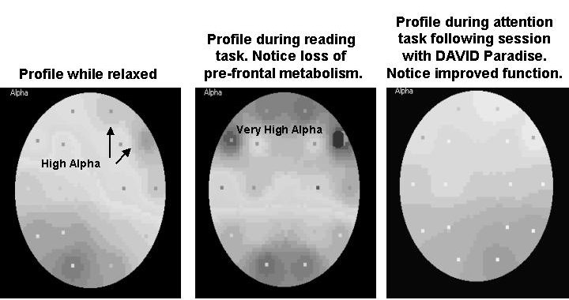

Glucose Uptake Characteristics of ADD

Considering that alpha is basically an “idling” rhythm, it would be logical to assume that both cerebral blood flow (CBF) and glucose metabolism would fall during periods of increased alpha activity. ADD children show hypo-perfusion of blood (as measured with functional magnetic resonance imaging) in the striatum (putamen), and this directly correlates with hyperactivity (Teicher, et. al., 2000). When the same children are treated with methylphenidate, the relative increase in blood flow through the putamen directly correlates with reductions in hyperactivity.

Single Photon Emission Computerized Tomography (SPECT) is a process where a small amount of radioactive tracer is put into the blood stream through an artery. The parts of the brain that receive the most blood flow also absorb the most tracer through metabolism which shows up as a bright area on the image. Areas that don’t absorb any radioactive tracer appear as black. Figure 2 shows the pre-frontal blood flow and metabolism in a person diagnosed with ADD (Amen, 1998, p.123). Notice that the pre-frontal lobes do not function well at the best of times. During concentration the pre-frontal lobes shut down quite completely, making it very difficult for this person to pay attention and process what is being read. After an application of Adderal, pre-frontal lobe function improves considerably, improving attention and reducing hyperactivity. Notice the similarities between the black “holes” in Amen’s SPECT (centre image) and the alpha inversion shown on the brain map (centre image) during the task conditions. Both Adderall and AVE increase cerebral blood flow. Notice the “smoothing” of brain function in Amen’s third image and the alpha “smoothing” following AVE on the DAVID Paradise.

Figure 2 SPECT Images of ADD Profiles

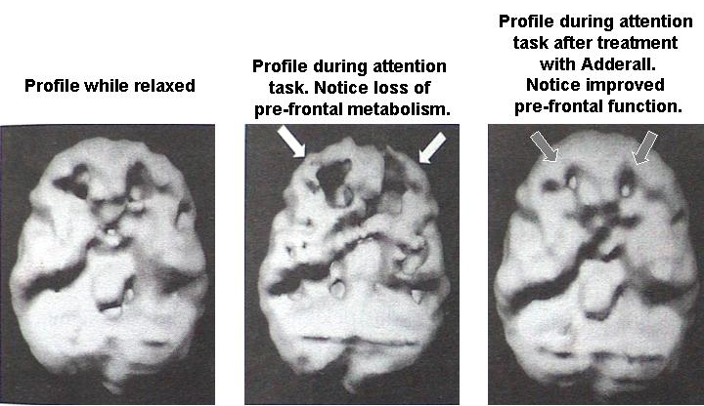

The Educational Challenge of ADD (excerpted from Michael Joyce – New Vision School, Minneapolis, MN)

Traditionally, educators have viewed conditions such as ADD, ADHD, and Obsessive Compulsive Disorder (OCD) as primarily medical conditions and therefore outside the realm of education. Typically, children with such conditions are referred to the medical world to identify an appropriate medication to ameliorate the problem behavior.

Children with ADHD are often disruptive in the classroom, require frequent teacher input, do not generally keep up with their peers in academic pursuits, and often require additional services due to their significant difficulty with all aspects of learning. Additionally, many children are misdiagnosed and actually have conditions of depression and anxiety. Medicating such children with stimulant medications in these cases is contraindicated and may make their conditions significantly worse. More recently, schools have become involved to a much greater degree, and now provide screening tests to identify students with attentional disorders.

This scenario suggests that a training program that results in more or less permanent resolution of ADHD symptoms would be preferred over the traditional medication management approach. NeuroTechnology (NT) is such an approach. NT, comprising neurofeedback and AVE, has been studied extensively in clinical and research settings for the past twenty years. Because intervention with NT is a training process and not a clinical intervention, it is more appropriately applied in the educational setting rather than in the clinical setting. It is also clear that this intervention will not be available through medical channels to the vast majority of children who need it due to the medical profession’s reliance on medication management, rather then educational approaches for such problems. Additionally, the evidence that medication compliance is significantly lower in low-income families suggests that applying NT in inner city and rural schools in low-income areas would be a more effective method of addressing such impediments to learning. Further, low-income students often cannot afford such training from a physician or psychologist and so do not have access to such an alternative approach for the remedy of their disability, even if it is available in their area.

Studies of Attentional Disorders Using AVE as a Treatment Modality

Throughout the 1980s there were a variety of case reports of improved attention and school grades when applying AVE to treat autism and ADD, but larger studies did not yet exist. Finally, in 1990, the first group study took place of the effects of AVE on 26 eight to twelve-year-old learning disabled boys from a private and public school (Carter & Russell, 1993).

In this study, fourteen children (from a private school) received two minutes of 10 Hz stimulation, 1 minute of no stimulation, and 2 minutes of 18 Hz for 5 cycles over a 25-minute period. The students received AVE once a day, five days per week for eight weeks, totalling 40 sessions. They also listened to a tape of binaural beats (recorded from the AVE sessions) for 40 sessions at home. The public school children (n=12) received three treatments per week for six weeks totalling 18 treatments. All children could see out of their eyesets, and were encouraged to play checkers and hand-held electronic games during the treatment.

The results of the first group were considerably better. They received 22 more AVE treatments than the public school children. Unfortunately this large difference in AVE treatment had confounded the study, making it unclear as to whether or not the binaural beats on cassette tape had any influence. Figures 3 and 4 show the pre-post results of IQ measures and the Burks Teachers’ Behavior Index for the private school children. Referring to Figure 4, which class of students would you want to teach?

Figure 3 Pre-Post IQ Rating
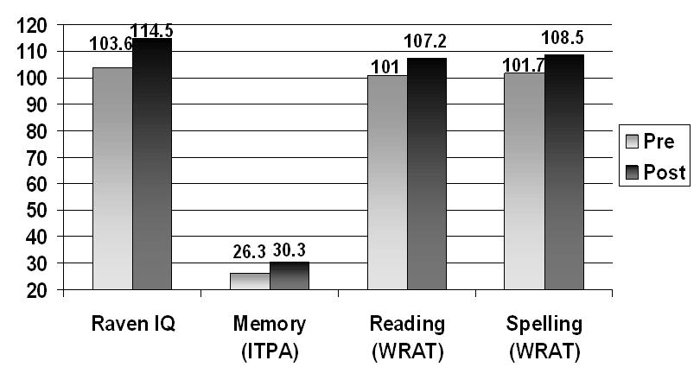

Figure 4 Pre-Post Burks Behavior Rating by Teachers
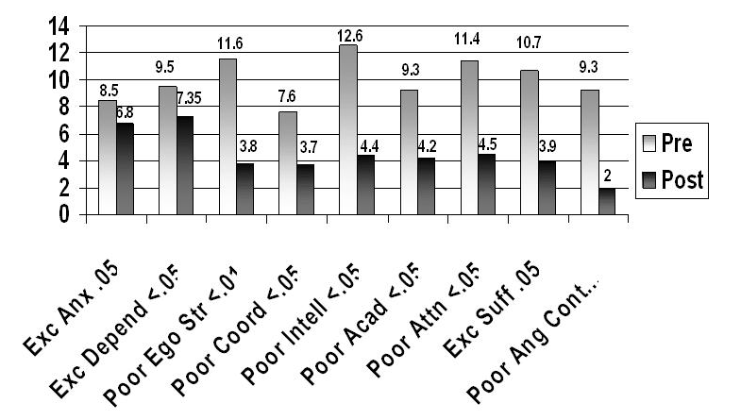

AVE Program as a Treatment for Behavior Disorders in a School Setting

In 1997, Michael Joyce began using a unique dual frequency AVE session using the TruVuTM eyesets (independent field stimulation used with the DAVID Paradise units) to treat ADD and reading-challenged students in two Minnesota primary schools (Joyce & Siever, 2000). He measured the children for changes in inattention, impulsiveness, reaction time, and variability as measured with the TOVA (Greenberg & Waldman, 1993), a computerized continuous performance test (CPT). Figure 5 shows the children’s improvements after an average of 33 sessions (over a ten-week treatment period). A normal score is 100. A score of 85 represents one standard deviation away from the norm and is considered aberrant. These results clearly show improvements in all TOVA measures.

Figure 5 Pre-Post TOVA Measures

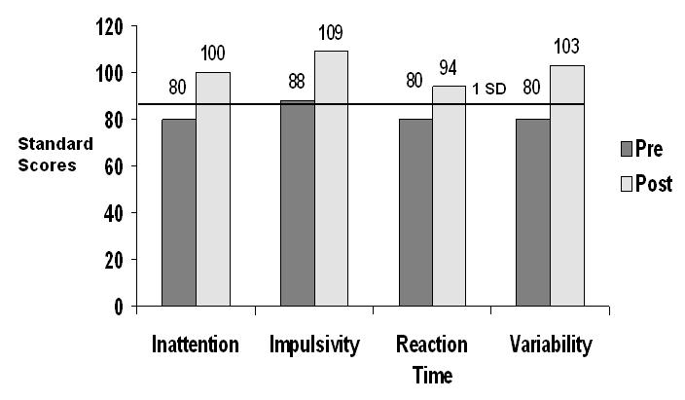

Joyce also evaluated reading ability in students from the SPALDING reading program school. The children were tested on the STAR (Standardized Test for the Assessment of Reading). Figure 6 shows their comparative improvements as compared with the controls’ performance. The grade equivalent (GE) ranges from grade 0 to 13 and represents a child’s actual grade reading level. For instance, if a child is assessed with a GE of 4.7, then the child is reading at the level a typical child in the seventh month of grade 4. Figure 6 shows the differences in performance between the treatment (AVE) group and the control group. The percentile rank (PR), ranging from 1 to 99, shows a student’s performance compared to his/her peers nationally. For instance, if a child has a PR of 78, then the student is performing at a level that equals or exceeds that of 78% of the children in the same grade, based on the national average. This measure shows that the control group performance decreased slightly while the AVE group improved considerably.

Figure 6 Pre-Post Differences in Reading (STAR) Measures

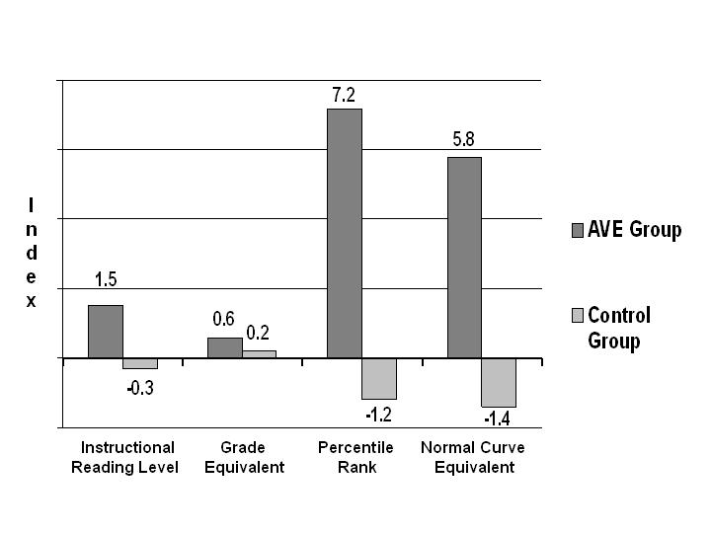

The Brain Blood-Flow Connection

Cerebral Blood Flow (CBF) has been examined in other disciplines concerned with cognition. For instance, vinpocetine, an extract from the periwinkle plant has been shown to increase CBF (Gold, et. al., 2003). In studies of seniors with memory problems or dementia-related disease, the use of vinpocetine produced improvements in attention, concentration and memory.

Hershel Toomim, a long-time pioneer in the field of neurofeedback (NF), has examined the role of cerebral blood flow in brain regulation and attentional disorders (Toomim & Toomim, 1999). He has been using a technique called hemo-encephalography (HEG), which measures the perfusion of cerebral blood flow, and has observed decreases in frontal blood flow in ADD children during reading. By translating the HEG measures into auditory biofeedback, Toomim has been able to train such children to increase CBF. He reports results greater than those of traditional NF. Because of the cerebral blood connection between HEG and AVE, Toomim (2001) analysed six well-respected NF studies (studies with ADD children) and found that the Joyce study, while treating ten children simultaneously, showed better improvements on the TOVA than had NF, conducted with one child at a time (Figure 7).

Figure 7

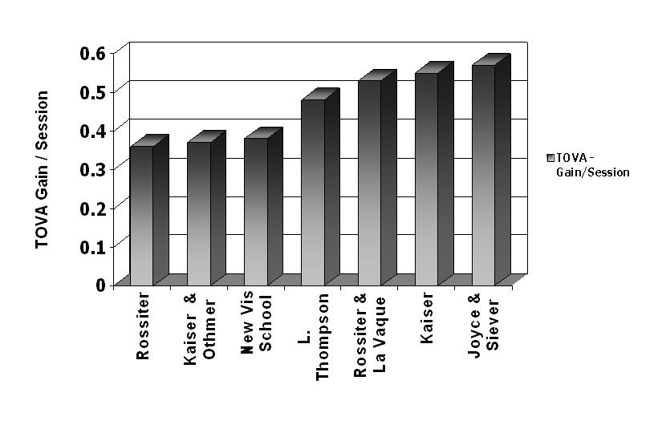

Academic Performance and the Alpha Rhythm - Revisited

Several studies have been completed showing the comparison between peak alpha frequency and intelligence. In 1996, Anoukhin and Vogel observed 101 healthy males ranging from 20 to 45 years of age. They discovered that those who scored well on the Raven’s IQ tests had a scant 1 Hz faster alpha rhythm than did the poor performers. In 1971, Oloffson reported that healthy human alpha production was in the range of 9.3 - 11.1 Hz. A 1990 study by Markand showed that a dominant alpha frequency of 8.5 Hz or lower reflected a state of mental dysfunction. Other studies by various research teams; Vogt, Klimesh and Doppelmayr (1998), Jausovec (1996), Giannitrapini (1969) showed a distinctive relationship between mental performance and peak alpha frequency. Roughly speaking, peak alpha production of less than approximately 10 Hz can be associated with poorer than average academic performance while dominant alpha production higher than 10 Hz is associated with better than average academic performance.

The above findings prompted Budzynski and Tang (1998) to conduct a “peak alpha” experiment with AVE. Fifteen minutes of photic stimulation at 14 Hz was given to 14 people. Peak alpha frequency was found to increase following the cessation of photic stimulation. The pre-stimulation dominant alpha average frequency was 9.78 Hz., which continually increased to 10.38 Hz., 20 minutes post stimulation (the latest measure taken).

Budzynski Study Using AVE to Improve Cognition
and Academic Performance in College Students

Tom Budzynski and colleagues (1999) further divided the typical alpha band (8 - 13 Hz) into three separate bands. Band “A1” represented 7-9 Hz, “A2”, 9-11 Hz, and “A3”, 11-13 Hz. They then examined the A3/A1 ratio. If, for example, there was 15 μv of A3 activity and 12 μv of A1 activity, the ratio would be A3/A1= 1.25. Based on previous findings, a ratio exceeding “1” was considered to equate with better than average mental performance, while a score below “1” equated with poorer than average mental performance.

A group of struggling college students (n=8), defined as those receiving tutoring, attending the Western Washington University, were chosen for the study. EEGs were collected and the A1/A3 ratios were calculated while the students were attending to a variety of mental tasks. As shown in Figure 8, average alpha slowing (as indicated by the negative ratio) was apparent across all measures and in particular alpha slowing was most apparent during the Digit Span task. This task requires remembering progressively longer strings of numbers until they can no longer be remembered. Following 30 sessions of repeating cycles of 14 and 22 Hz AVE, mean alpha frequency (positive ratio) increased. The positive alpha ratio continued across all tasks, indicating heightened mental performance (a reversal of the control group).

Figure 8

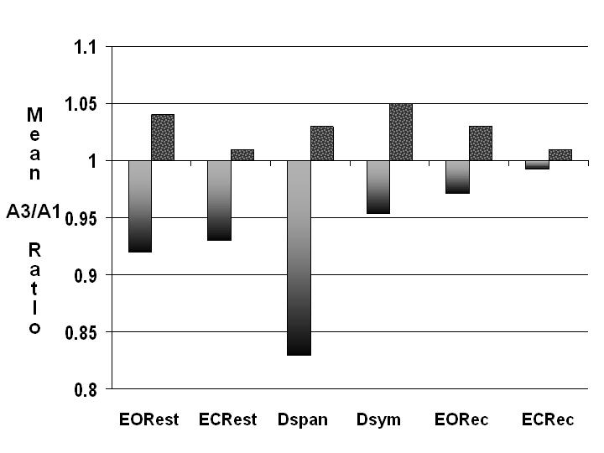

The 30 AVE sessions were completed in the Fall of 1997 and the students’ marks from their spring exams were recorded and compared against a control group (Figure 9). Notice the AVE group showed improvement in grade-point average (GPA) over the course of the year while the controls showed a decrease in GPA. This study demonstrates that the carry-over effect following the cessation of AVE treatment continued for at least five months.

Figure 9
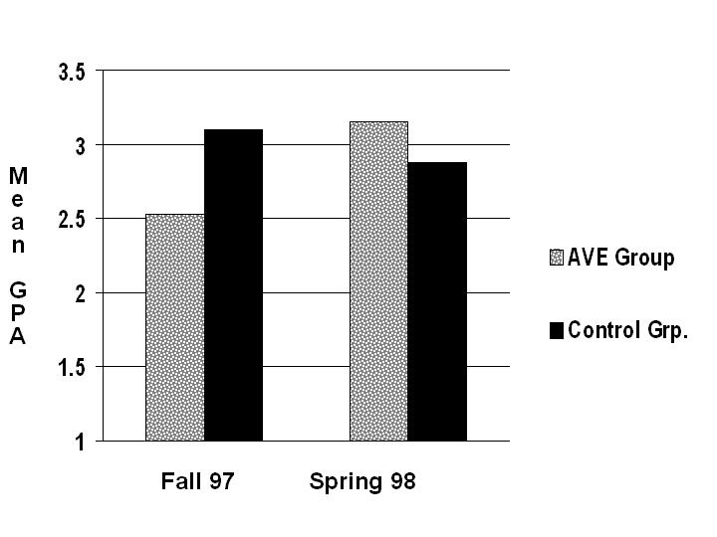

Comparing AVE with Psycho-Stimulants in the Treatment of ADHD in Children

This study by Lawrence Micheletti is unique in that it compares outcomes of an AVE group with a Ritalin/Adderall group, and with an AVE and stimulant combined group (total N = 99). A control group was also included in the study. The demographics are as follows:

Control Group N = 31
Stimulant (Ritalin & Adderall) Group N = 20
AVE Group N = 21
Combined AVE & Stimulant Group N = 27

Testing was done just prior to treatment (pre), immediately following (post) and after four weeks (post-post). I.Q. was tested on the Wide Range Achievement Test (WRAT), Peabody Picture Vocabulary Test (PPVP) and Raven’s Progressive Matrices (Raven). The children received a 20- minute session, five days a week for a total of 40 sessions. The researcher administered the first training session while the remaining 39 sessions were completed at home and were supervised and recorded by a parent or legal guardian.

The AVE unit was programmed to begin with both auditory and visual stimulation at 10 Hz for two minutes and at that time visual stimulation would cease and only auditory stimulation would continue for one minute. After the auditory-only stimulation, the AVE unit would switch to both auditory and visual stimulation at 18 Hz for two minutes. The children experienced four complete cycles (five minutes per cycle) for the completion of a 20-minute training session. Absolute measures were taken, but for the purpose of this article, only the comparative data between the controls, the Ritalin Group, the AVE Group and the Combined AVE & Stimulant Group are shown (Figure 10).

Figure 10

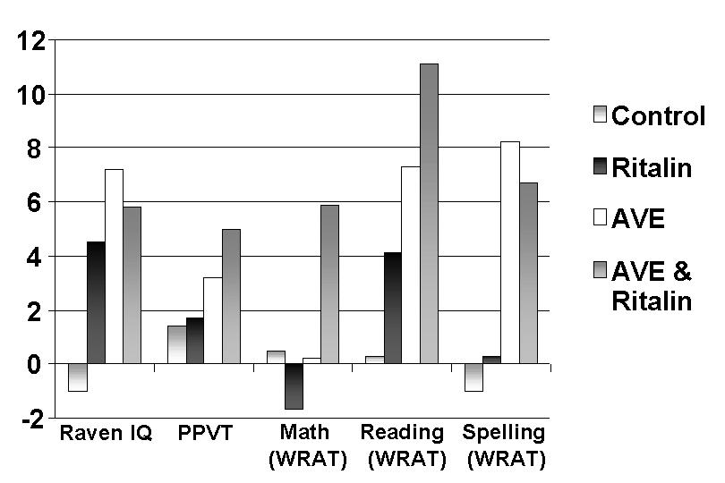

New Visions School Neurotechnology Replication Project

In 2001, Michael Joyce, at the New Visions School (A Chance To Grow), a charter school in Minneapolis specializing in special needs children (attentional and behavioral), completed the largest AVE study to date. This study substantiated previous work in schools in Minneapolis and Perham, MN, and in Yonkers, NY. The study illustrated that the public school setting is an ideal environment for conducting AVE training, particularly for low-income inner city and rural families who typically do not have access to such training. This study involved the efforts of seven Minnesota public schools (five elementary, one middle, and one K-12) with the majority of elementary age. This study employed AVE to address the inattention, impulsiveness and behavioral challenges in school-age children, thus reducing the need for medication management of these children and reducing the educational resources that are devoted to responding to their disabilities.

Students selected had a history of learning and reading challenges, impulsiveness, and a propensity to be distracted and to distract others. The students were selected by an ongoing, dynamic evaluation process based upon referrals from classroom teachers, parents, special education staff, and/or other concerned people in the student’s life. Parents and teachers completed a behavior rating scale, while the students completed a standardized reading inventory.

Apparatus

The AVE device used was the DAVID Paradise XL (manufactured by Mind Alive Inc, Edmonton, Alberta, Canada). The eyesets used in the study were field independent, in that they are able to independently stimulate the individual left and right visual fields of each eye thus producing a different frequency in each hemisphere of the brain.

At two schools, the DAVID Paradise XL was attached to a multi-user amplifier, which enabled up to ten students to receive treatment simultaneously (Figure 13). Each student had his/her own station, which consisted of a set of headphones and an eyeset. The students could control both the audio volume and the light intensity. The students preferred brighter intensities, between approximately 400 and 600 lux (full spectrum) measured approximately 0.3 inches from the eye set screen (approximating their average eye distance from the screen).

Students participated in two or three AVE sessions (20 to 30 minutes each) per week, averaging nearly 30 sessions over a period of three months. Some students with severe impairments underwent daily sessions. The training was part of the student’s regular curriculum, scheduled around other activities. Training was accomplished using protocols established by the foremost clinicians and researchers in the field, modified to reflect New Visions’ experience working within the school environment.

Results

Pre- and post-intervention data was obtained using direct assessment and behavior rating scales completed by both parents and teachers. Behavioral and personality ratings were obtained via the BDS, both the home and school versions and normed to a value of “10” (Figure 11). Oral reading proficiency was assessed with the Slosson-R reading test. Students showed reductions in anxiousness, depression, hyperactivity and inattention. On average, students gained eight months (p<.001) in grade-equivalent oral reading scores (Figure 12).

Figure 11
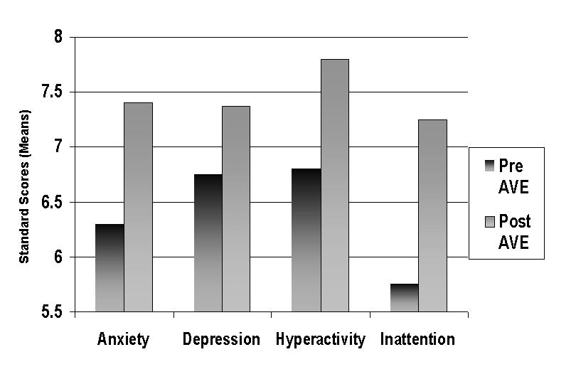

Figure 12

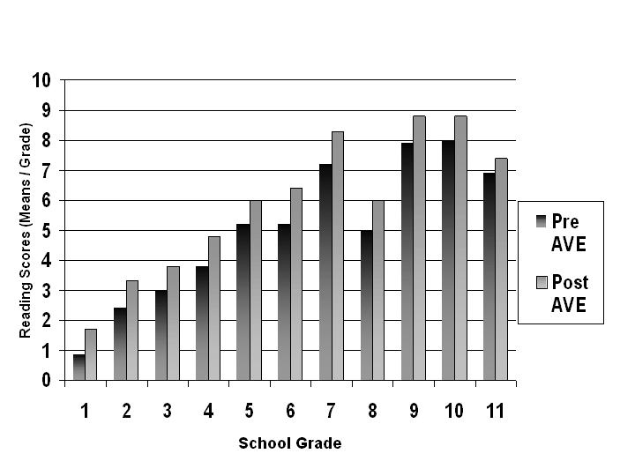

Shown below in Figure 13 is Michael Joyce’s storage box containing the AVE Multiple System. Joyce’s box has an audio-mixer that “mixes” a microphone and CD player into the multiple system for the children to hear. These storage systems, which are used throughout several schools are on wheels so that they may be easily transported throughout the schools for use in different classrooms.

Figure 13

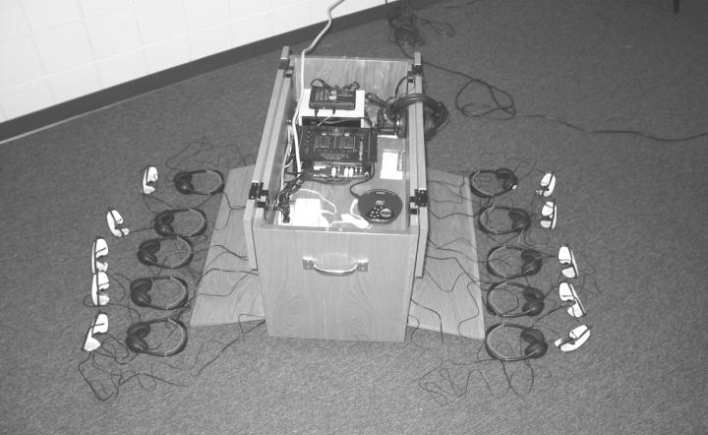

Conclusion

Several studies show that AVE is a useful tool for treating attentional disorders. The frequencies used in its operation are similar to those frequencies used with common NF techniques. As added bonuses, the ability to have pre-programmed sessions makes AVE easy to use by people not skilled in NF, such as teachers and parents. A single clinician may also treat several children at one time, thus drastically cutting costs. The results include many behavioral improvements in addition to the primary attentional concerns.

References

Amen, D. (1998). Change your brain, change your life. New York: Three Rivers Press.

Anoukhin, A. & Vogel, F. (1966). EEG alpha rhythm frequency and intelligence in normal individuals. Intelligence, 23, 1-14.

Barkley, R., McMurray, M., & Edelbrock, C. (1989). The response of aggressive and non-aggressive ADHD children to two doses of methylphenidate. Journal of American Academy of Adolescent Psychiatry. 28, 873-881.

Budzynski, T. & Tang, J. (1998). Biolight effects on the EEG. SynchroMed Report. Seattle, WA.

Budzynski, T., Jordy, J., Budzynski, H., Tang, H., & Claypoole, H. (1999). Academic performance enhancement with photic stimulation and EDR feedback. Journal of Neurotherapy, 3 (3), 11-21.

Carter, J. & Russell, H. (1993). A pilot investigation of auditory and visual entrainment of brain wave activity in learning disabled boys. Texas Researcher. Vol 4, 65-72.

Chabot, R. & Serfontein, G., (1996). Quantitative electroencephalographic profiles of children with attention deficit disorder. Biological Psychology, 40, 951-963.

Cohen, N & Douglas, V. (1972). Characteristics of the orienting response in hyperactive and normal children. Psychophysiology, 9 238-245.

Cripe, F. (1986). Rock music as therapy for children with attention deficit disorder: An exploratory study. Journal of Music Therapy, 23 (1), 550-562.

Giannitrapani, D. (1969). EEG average frequency and intelligence. Electroencephalography & Clinical Neurophysiology, 27, 480-486.

Gold, P., Cahill, L., & Wenk, G. (2003, April). The lowdown on ginko biloba. Scientific American, 86-91.

Greenberg, L. & Waldman, I. (1993). Developmental normative data on the test of variables of attention (TOVA). Journal of Child and Adolescent Psychiatry, 34 (6), 1019-1030.

Gurnee, R. (2000). QEEG based subtypes of adult ADHD and implications for treatment. Annual Proceedings. snr-jnt.org/nfbarch/abstracts/2000/2k-papers.htm

Hunt, R., Hoehn, R., Stephens, K., Riley, W., & Osten, C. (1994). Clinical patterns of ADHD: A treatment model based on brain functioning. Comprehensive Therapy. 20 (2), 106-112
Jausovec, N. (1996). Differences in EEG alpha activity related to giftness. Intelligence, 23, 159-173.

John, E., Karmel, B., Corning, W., Easton, P., Brown, D., Ahn, H., John, M., Harmony, T., Prichep, T., Toro, A., Gerson, I., Bartlett, F., Thatcher, R., Kaye, H., Valdes, P., & Schwartz, E. (1977). Neurometrics: Numerical taxonomy identifies different profiles of brain functions within groups of behaviourally similar people. Science, 196, 1393-1410.

Joyce, M., & Siever, D. (2000). Audio-visual entrainment program as a treatment for behavior disorders in a school setting. Journal of Neurotherapy. 4, (2) 9-15.

Joyce, M. (2001). New Vision School: Report to the Minnesota Department of Education, unpublished.

Klimesh, W., Doppelmayr, M., Pachinger & Ripper, B. (1997). Brain oscillations and human memory: EEG correlates in the upper alpha and theta band. Neuroscience Letters, 238, 9-12.

Leuba, C. (1955). Toward some integration of learning theories: the concept of optimal stimulation. Psychological Reports. 1, 27-33.

Lubar, J., Bianchini, B., Calhoun, W., Lambert, E., Brody, M., & Shabsin, H. (1985). Spectral analysis od eeg differences between children with and without learning disabilities. Journal of Learning Disabilities, 18 (7), 403-408.

Lubar, J. & Lubar, J. (1999). Neurofeedback assessment and treatment for attention deficit/hyperactivity disorders. In J. R. Evans & A. Abarbanel (Eds.), Quantitative EEG and Neurofeedback (pp. 103-143). Academic Press, San Diego.

Markand, O. (1990). Alpha rhythms. Journal of Clinical Neurophysiology, 7, 163-189.

Micheletti, L., The use of auditory and visual stimulation for the treatment of attention deficit hyperactivity disorder in children. MichelettiUniversity of Houston. Ph.D. dissertation manuscript. Available from Mind Alive Inc.

Oken, B., & Salinsky, M. (1992). Alertness and attention: Basic science and electrophysiologic correlates. Journal of Clinical Neurophysiology, 9 (4), 480-494.

Siever, D. (2000). The rediscovery of audio-visual entrainment technology. Unpublished manuscript.

Siever, D. (2002). New technology for attention and learning. Unpublished manuscript.

Sterman, M. B. & Kaiser, D. A., (2001). Comodulation: A new QEEG analysis metric for assessment of structural and functional disorders of the CNS. Journal of Neurotherapy, 4 (3), 73-83.
Sterman, M. B. (1999). Atlas of topometric clinical displays. Los Angeles, CA: Sterman-Kaiser Imaging Laboratory.
Tansey, M. (1985). Brainwave signatures: An index reflective of the brain’s functional neuroanatomy: Further findings on the effect of EEG sensorimotor rhythm biofeedback training on the neurologic precursors of learning disabilities. International Journal of Psychophysiology. 3, 85-89.

Shealy, N., Cady, R., Cox, R., Liss, S., Clossen, W., & Veehoff, D. (1989). A comparison of depths of relaxation produced by various techniques and neurotransmitters produced by brainwave entrainment. Shealy and Forest Institute of Professional Psychology. A study conducted for Comprehensive Health Care, Unpublished.

Teicher, M., Anderson, C., Polcari, A., Glod, C., Maas, L., & Renshaw, P. (2000). Functional deficits in basal ganglia of children with attention-deficit/hyperactivity disorder shown with functional magnetic resonance imaging relaxometry. Nature Medicine, 6 (4), 470-473.

Thatcher, R. (1998). Normative EEG databases and EEG biofeedback. Journal of Neurotherapy, 2 (4), 8-39.

Toman, J. (1941). Flicker potentials and the alpha rhythm in man. Journal of Neurophysiology, 4, 51-61.

Toomim, H. & Toomim, M. (1999). Clinical observations with brain blood flow biofeedback
- the Thinking Cap™. Journal of Neurotherapy, 3 (4), 73.

Toomim, H. (2001). Unpublished report.

Vogt, F., Klimesh, W., & Doppelmayr, M. (1998). High-frequency components in the alpha band and memory performance. Journal of Clinical Neurophysiology, 15, 167-172.

Zentall, S. (1975). Optimal stimulation as theoretical basis of hyperactivity. American Journal of Orthopsychiatry, 45 (4), 549-562.

Zentall, S. & Zentall, T. (1976). Activity and task performance of hyperactive children as a function of environmental stimulation. Journal of Consulting and Clinical Psychology, 44 (5), 693-697.

New Vision School – A Chance to Grow (Michael Joyce). Minneapolis, MN Ph: 612-706-5551

